Assignment 1

CSC3150

Student Number: 117010032

Student Name: 陈雅茜



**Task 1**

**Introduction: Environment and Steps to Compile**

This program is written to implement the functions which is able to fork a child process to evoke the external program. The parent process is able to catch the signal raised in child process and return the value. The program is implemented on C programming language on ubuntu (ubuntu version 16.04 and kernel version v4.8.0-36-generic). The user should input the test external file and the output will be the signal raised in the file.

This program will only support 15 signals which are:

SIGHUP, SIGINI, SIGQUIT, SIGILL, SIGTRAP, SIGABRT, SIGFPE, SIGKILL,

SIGBUS, SIGSEGV, SIGPIPE, SIGALARM, SIGTERM, SIGSTOP, SIGCHIL

Your command in your terminal should be like:i

sudo make clean

sudo make

./program1 ./filename

(the filename here should be the name of your external test file, the command should be under the program1 folder)

For example, your input file should be:

#include <stdio.h>

#include <signal.h>

#include <unistd.h>

#include <stdlib.h>

**int** main(**int** argc,**char**\* argv[]){

printf("------------CHILD PROCESS START------------\n");

printf("This is the SIGPIPE program\n\n");

raise(SIGPIPE);

sleep(5);

printf("------------CHILD PROCESS END------------\n");

**return** 0;

}

For example, the corresponding output file should be:

﻿process start to fork

I'm the Parent process, my pid = 20735

I'm the Child process, my pid = 20736

Child process start to execute the program

------------CHILD PROCESS START------------

This is the SIGPIPE program

Parent process receiving the SIGCHILD signal

child process get SIGPIPE signal

child process is broken pipe by broken pipe signal

CHILD EXECUTION FAILED!!

**Flow: How Did I Design My Program**

1. Create the fork in the user mode to fork a child process



1. The child process will execute the test program while the parent process will wait until the child process return.



1. The child process will raise the signal and return it to the parent process
2. The parent process will recognize the signal with WIFEXITED(status), WIFSIGNALED(status) and WIFSTOPPED(status) functions.

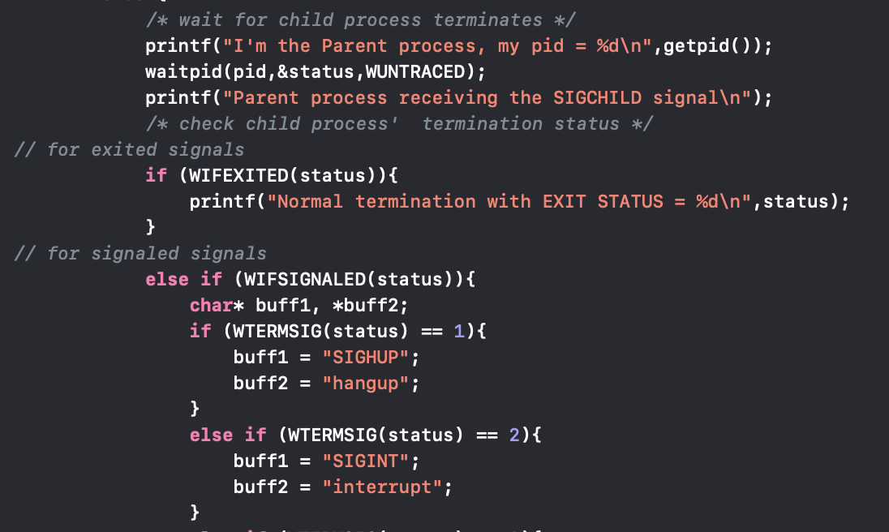

1. The parent process will use the WTERMSIG(status), WIFSTOPPED(status) and WEXITSTATUS(status) functions to further determine the signals’ specific type.
2. Return the type in terminal

(the flow is shown as below)



**Functions: How did I Design My Program**

pid = fork(); this function is used to fork the child process whose pid is equal to 0; You can check if the current process is parent process or child process by check if pid is zero or positive number.

waitpid(pid,&status,WUNTRACED); this function in the parent process is used to let the parent process wait for the child process to be finished. It will catch the signal in child process when the child process finish.

WIFEXITED(status), WIFSIGNALED(status) and WIFSTOPPED(status); these functions is used to check the state of signal raised in the child process. If the child process exit the WIFEXITED(status) will return non-zero(true), the other two functions will return zero(false). It is the same ideal with the other two functions.

WTERMSIG(status); this function is used when WIFSIGNALED(status) returns true and you want to further check the single type.

**Results: Screen Shot of My Output Result**

For the test file: normal, the return result in the terminal is

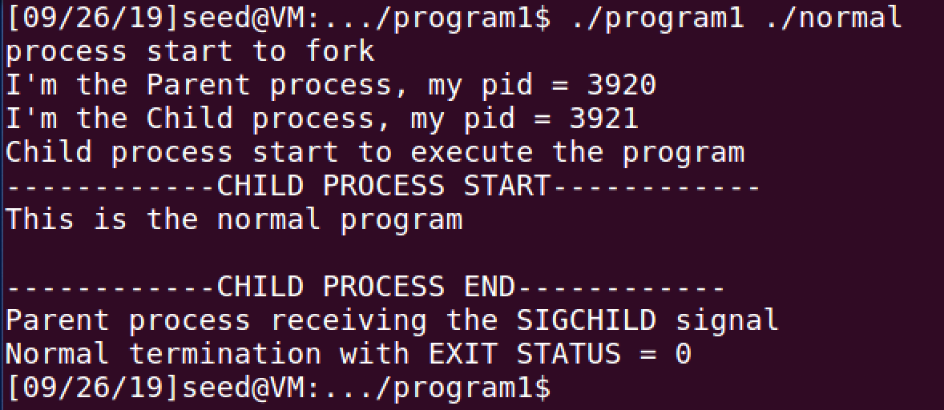

For the test file: abort, the return result in the terminal is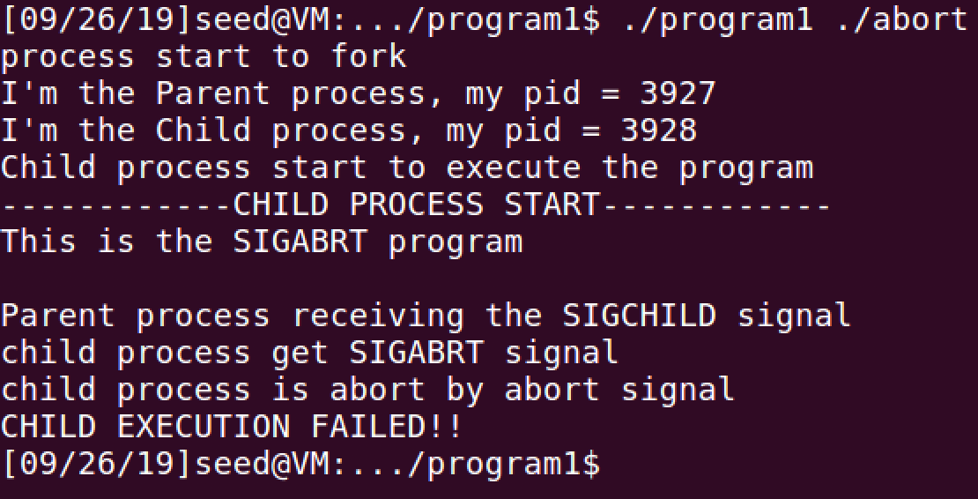

For the test file: stop, the return result in the terminal is

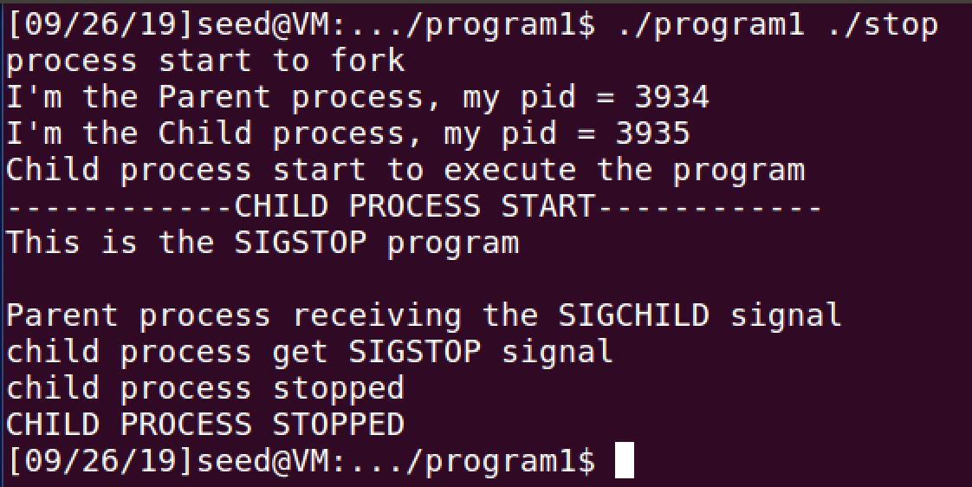

For the test file: alarm, the return result in the terminal is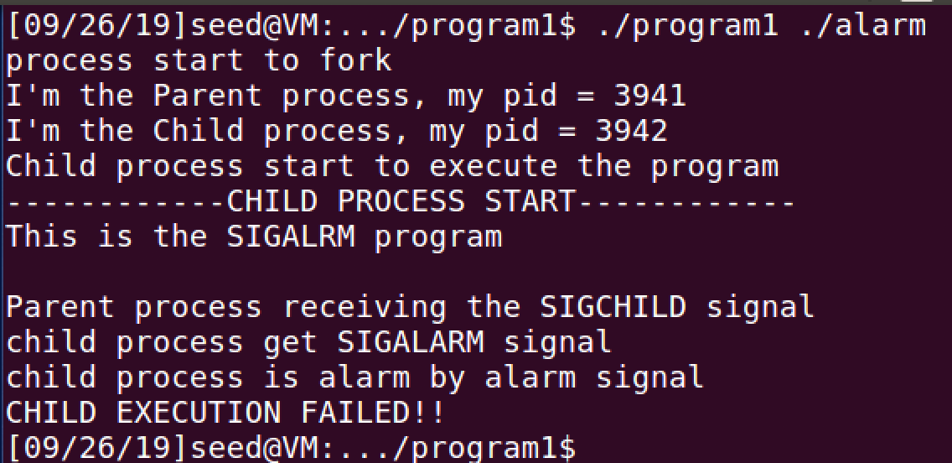

For the test file: bus, the return result in the terminal is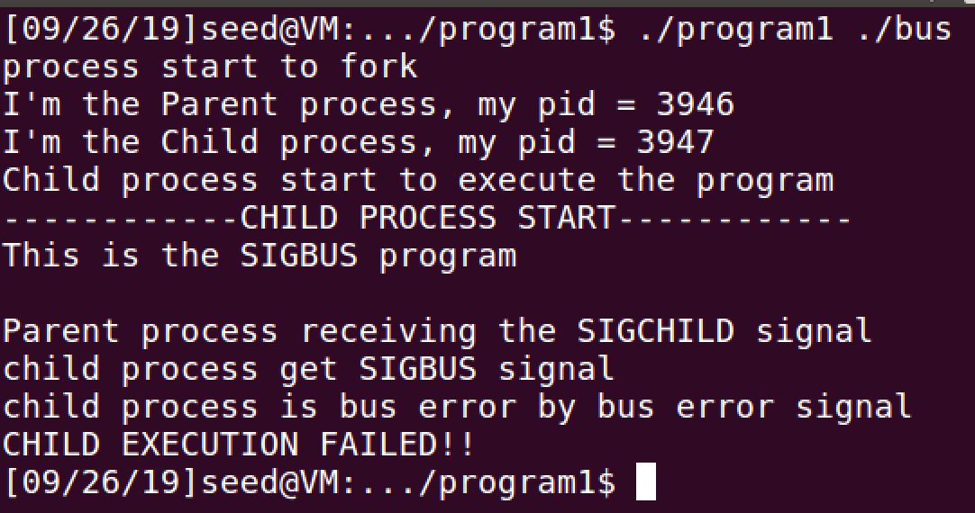

For the test file: floating, the return result in the terminal is

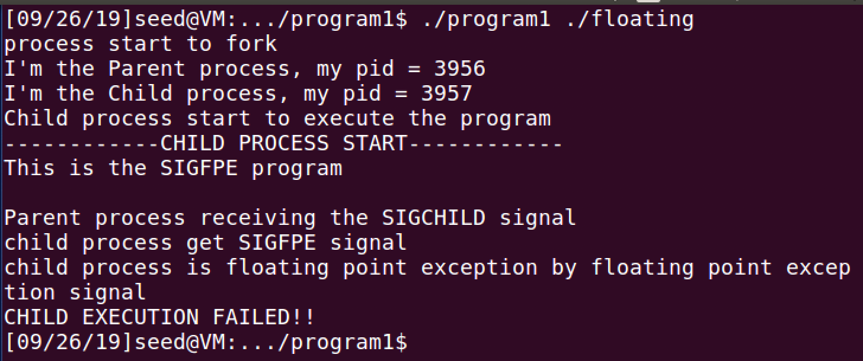

For the test file: hangup, the return result in the terminal is

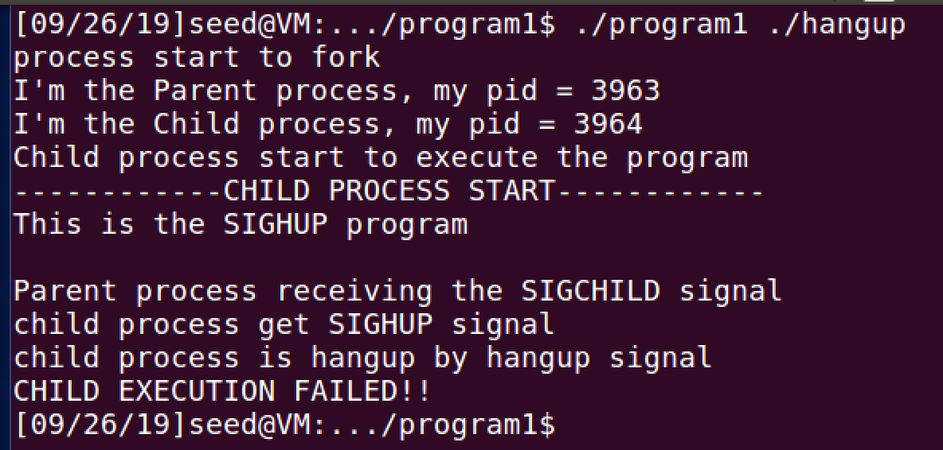

For the test file: illegal_instr, the return result in the terminal is

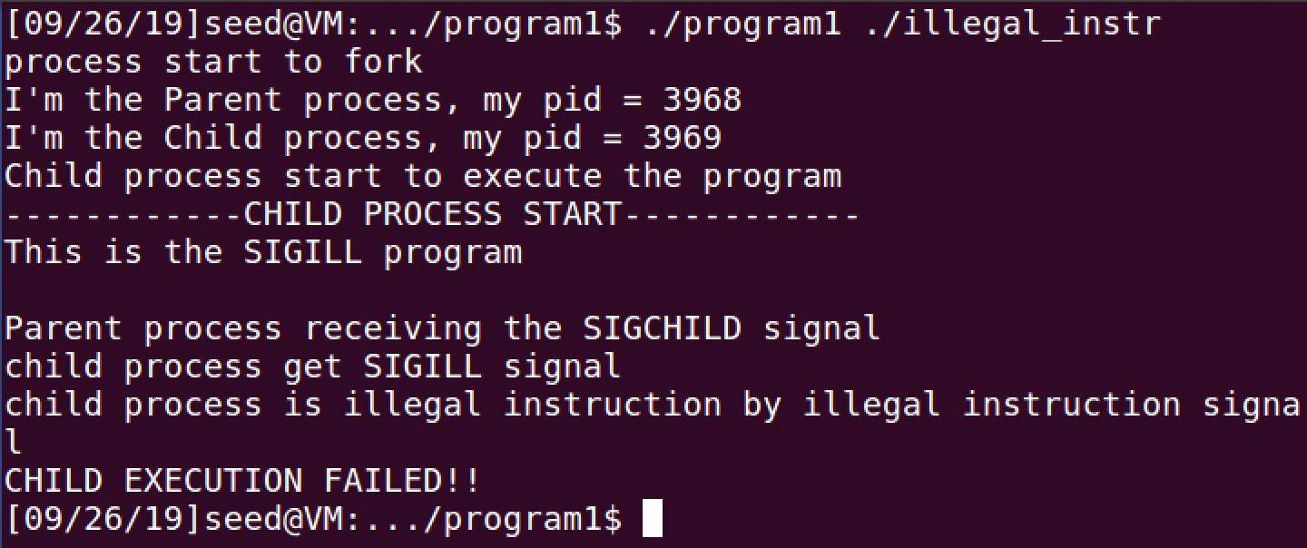

For the test file: interrupt, the return result in the terminal is

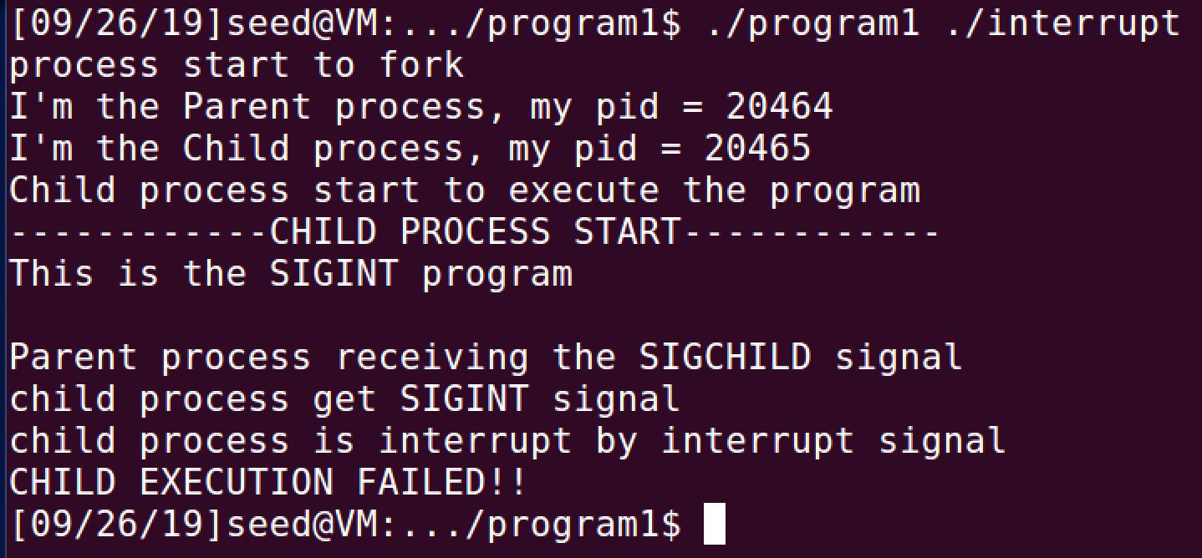

For the test file: kill, the return result in the terminal is

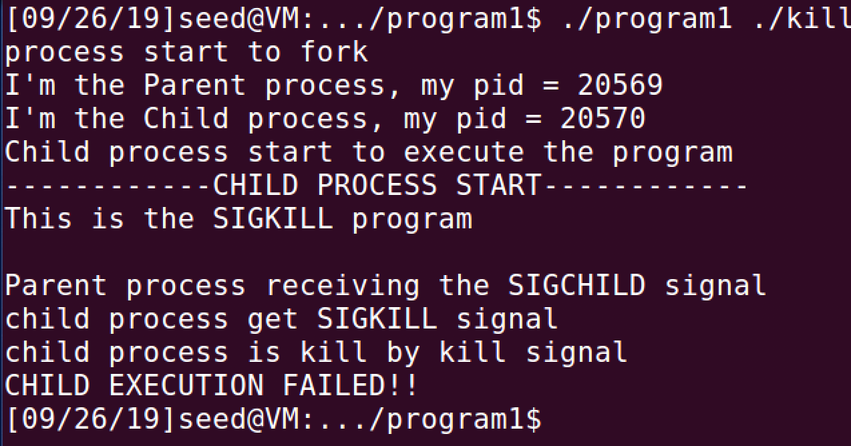

For the test file: pipe, the return result in the terminal is

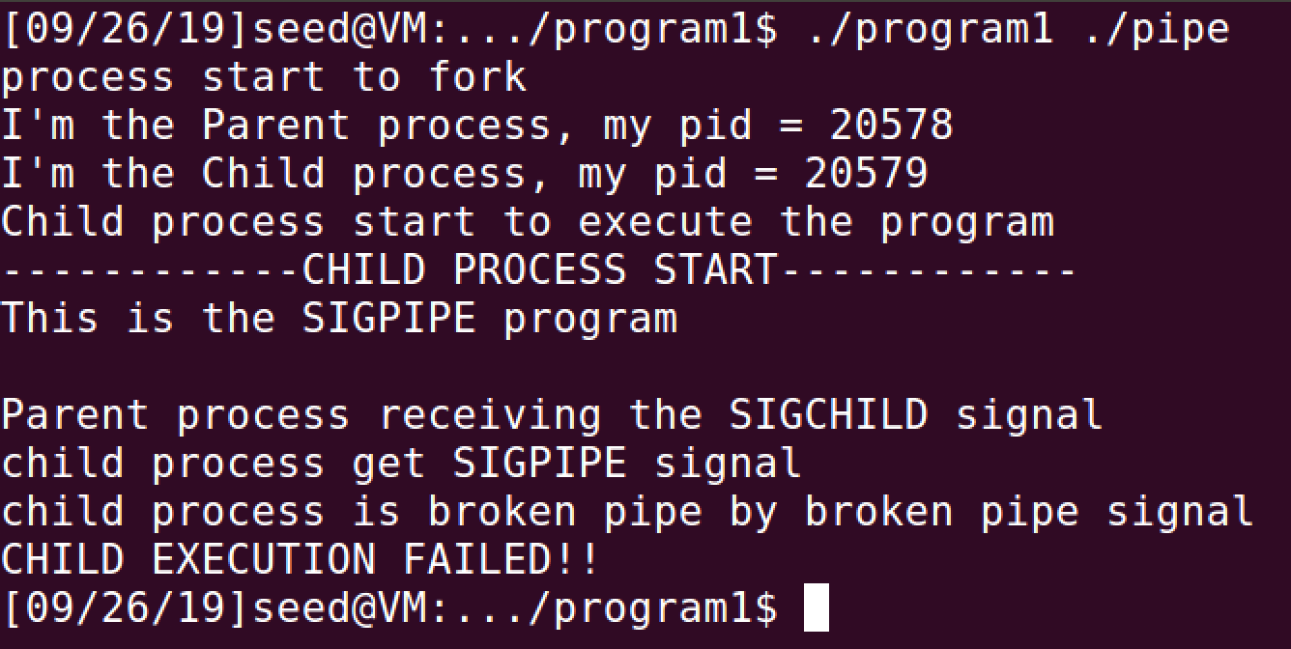

For the test file: quit, the return result in the terminal is

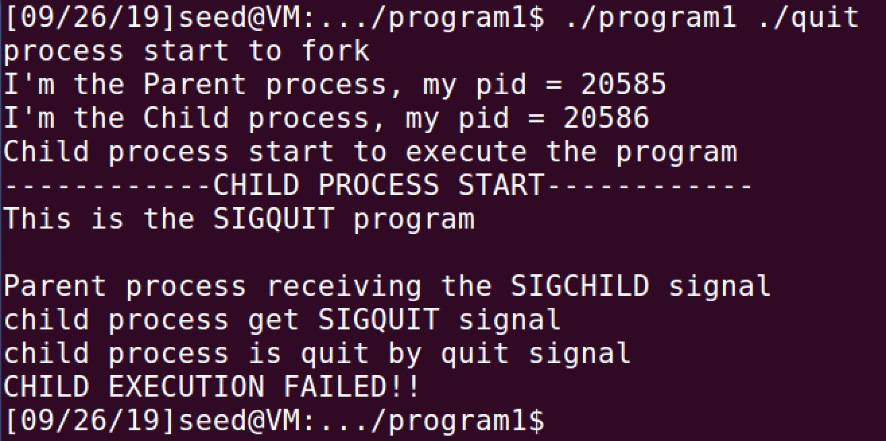

For the test file: segment_fault, the return result in the terminal is

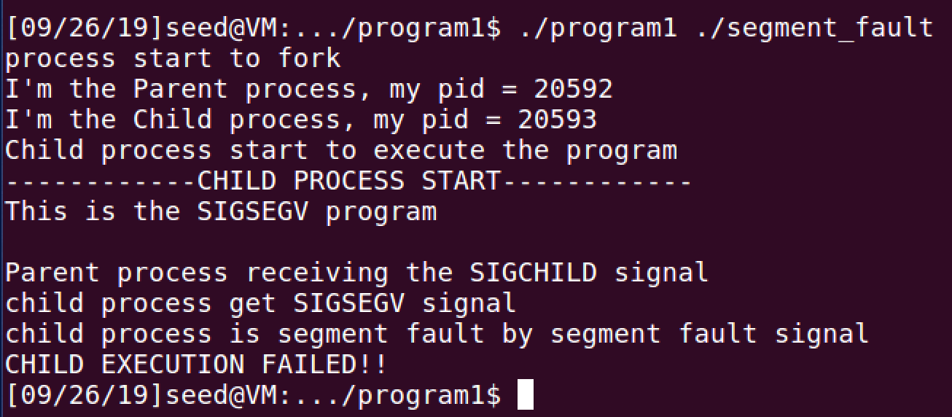

For the test file: fterminate, the return result in the terminal is

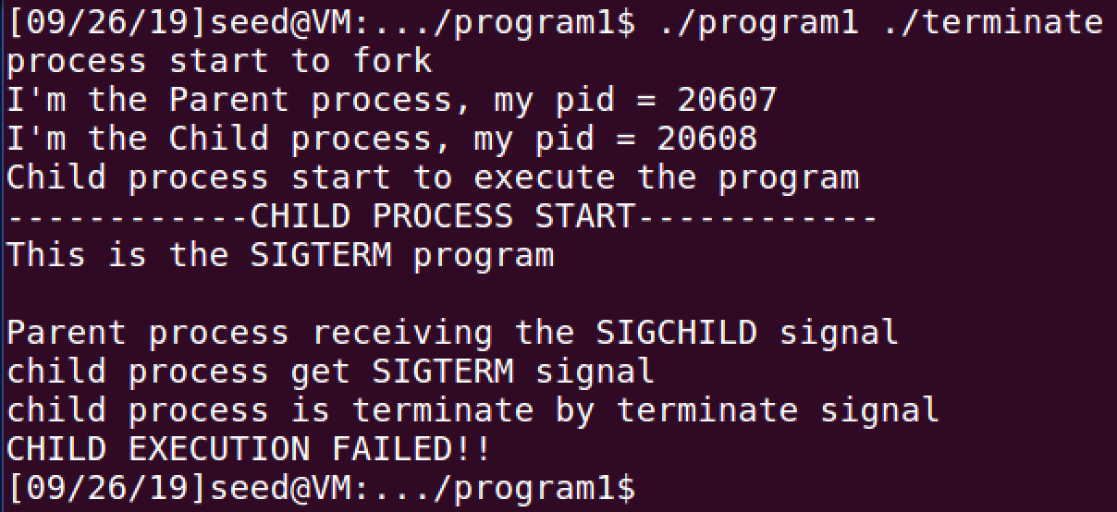

For the test file: trap, the return result in the terminal is

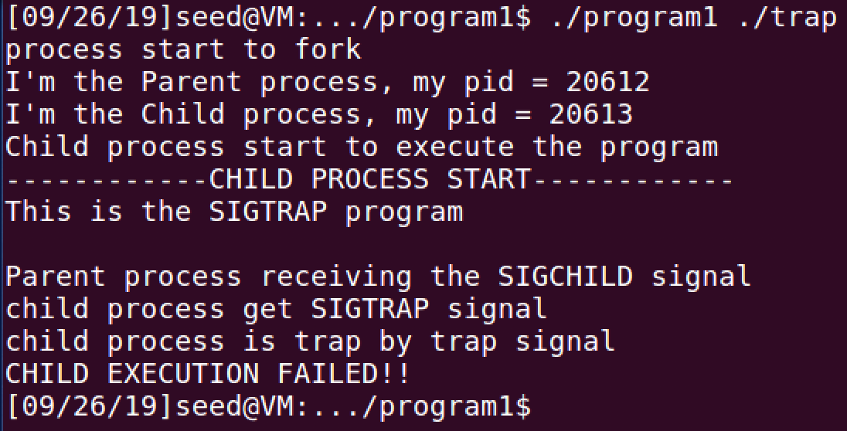

**Conclusion: What I have learnt from this program**

In this program I learnt 1) how to fork the child process, 2) how to execute the external file in the child process, 3) how to let the parent process wait for the child process and 4) how to determine the caught signal.

1. how to fork the child process

You should use the fork() function in the program to fork a child process. The function will return the parent process pid(process identifier) for the parent process, return 0 for the child process and return -1 if the fork failed. The variable type for the pid is pid_t.

After the child process being forked, the system will return an identical program in child process. Both child process and parent process will continue to execute the line after the fork function.

The getpid() function will return the pid of the current process and the ppid() function will return the pid of the parent of current process.

1. how to execute the external file in the child process

There are multiple functions for executing an external program in a child process, which are following



They are of the same function but with different input parameters. After execve() function, the child process will start to execute the external program from the very beginning. Any code in the child process after the execve() function will not be executed.

The function will not return anything if the execution function succeeds. It will return -1 if fails.

1. how to let the parent process wait for the child process

Since the terminated child process without parent’s wait will become a zombie and the terminated child process with parent’s termination will become an orphan, it is important to make sure that parent process will wait for the child process to terminate with wait() function or waitpid() function.

The wait function only requires the status of the child process while the waitpid function need three input parameters which are pid, status and option. The waitpid function has three options which are 0, WNOHANG and WUNTRACED.

0 skips the option, WNOHANG requires the signal information immediately and WUNTRACED option will wait for the child process to terminate and return the signal information.

1. How to Determine the Caught Signal

There are 64 signals in linux and each of them have a corresponding signal code. The code and the signal can be shown by typing kill -l in the terminal.

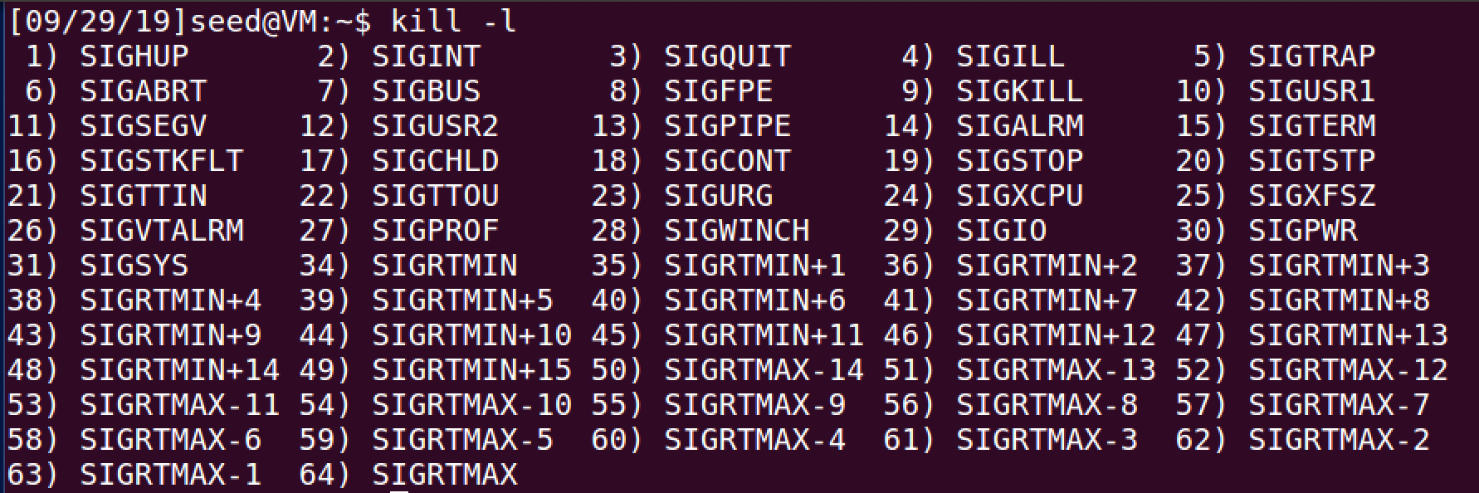

The signals are divided into three categories which are exited, signaled and stopped. The three categories of signals can be detected by WIFEXITED, WIFSIGNALED, WIFSTOPPED separately. The WIFEXITED signal will return if the process exited smoothly, the system will usually ignore such signals. The WIFSIGNALED signal will return if the process is terminated. The WIFSTOPPED signal will return if the process is stopped.

The function needs the status of the child process as the input and output the integer value. If the signal belongs to the corresponding category, the function will return non-zero, otherwise it will return 0.

In order to find the specific signal code for each signal. We can also use WEXITSTATUS, WTERMSIG, WSTOPSIG for each category.

**Task 2**

**Introduction**

This program is to implement a kernel module and insert it. The kernel module will firstly fork a child process and let the child process execute the test program. The program is able to catch the signal and return it in the kernel log. The program is implemented on C programming language on ubuntu (ubuntu version 16.04 and kernel version v4.8.0-36-generic). The kernel folder (version linux-4.10.14) is also required to execute the program and you need to make sure the “_do_fork”, “do_execve”, “getname” and “do_wait” functions in the kernel file is non-static. The user also needs to use EXPORT_SYMBOL_GLP (function_name) function to help you provide APIs to other modules. The user should input the test external file and the output will be the signal raised in the file.

This program will only support 15 signals which are:

SIGHUP, SIGINI, SIGQUIT, SIGILL, SIGTRAP, SIGABRT, SIGFPE, SIGKILL,

SIGBUS, SIGSEGV, SIGPIPE, SIGALARM, SIGTERM, SIGSTOP, SIGCHIL

You should execute the program following below steps:

1. Type “gcc -o test test.c” command under the program2 folder to compile test file.
2. Type “sudo make” command under the program2 folder to make the program2 file.
3. Type “sudo insmod program2.ko” command under the program2 folder to insert the kernel module into kernel.
4. Type “dmesg” command under the program2 folder to show the message

For example, your input test file should be like

#include <unistd.h>

#include <stdio.h>

#include <signal.h>

**int** main(**int** argc,**char**\* argv[]){

**int** i=0;

printf("--------USER PROGRAM--------\n");

*// alarm(2);*

raise(SIGBUS);

sleep(5);

printf("user process success!!\n");

printf("--------USER PROGRAM--------\n");

**return** 100;

}

For example, the corresponding output file should be like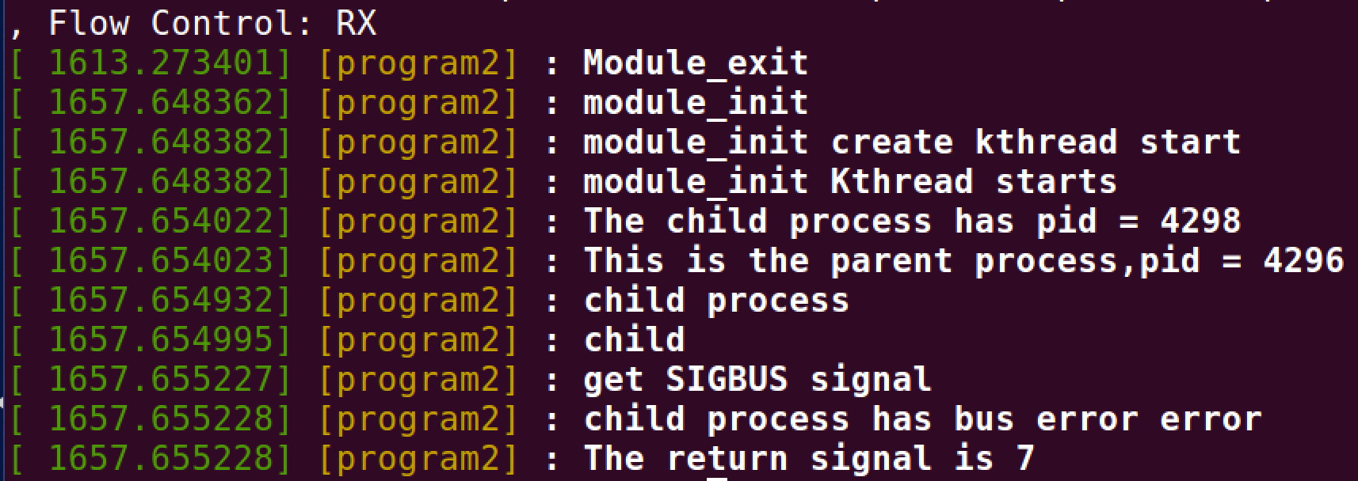

**Flow**

1. Firstly, extern the needed functions in order to use them in your module.



1. Then, the program should initialize the kernel module and create a kernel thread using the __init program2_init(void) function. It checks if the initialization success to wake up the process.



1. After that, the child process will automatically evoke my_fork function whose implementation is shown as below. In the my_fork function, the program will set the default sigaction for the current process, fork a child process using the do_fork function, let the child process execute the my_exec function and let the parent process wait for the child process finish.



1. The child process will then execute the my_exec function which will let the child process to execute the external test file. When the test file returns the valid result, the child process will exit with the do_exit(result) function.
2. The parent process will wait for the child process to finish with the my_wait function. It will also check the return signal type with the *wo.wo_stat. 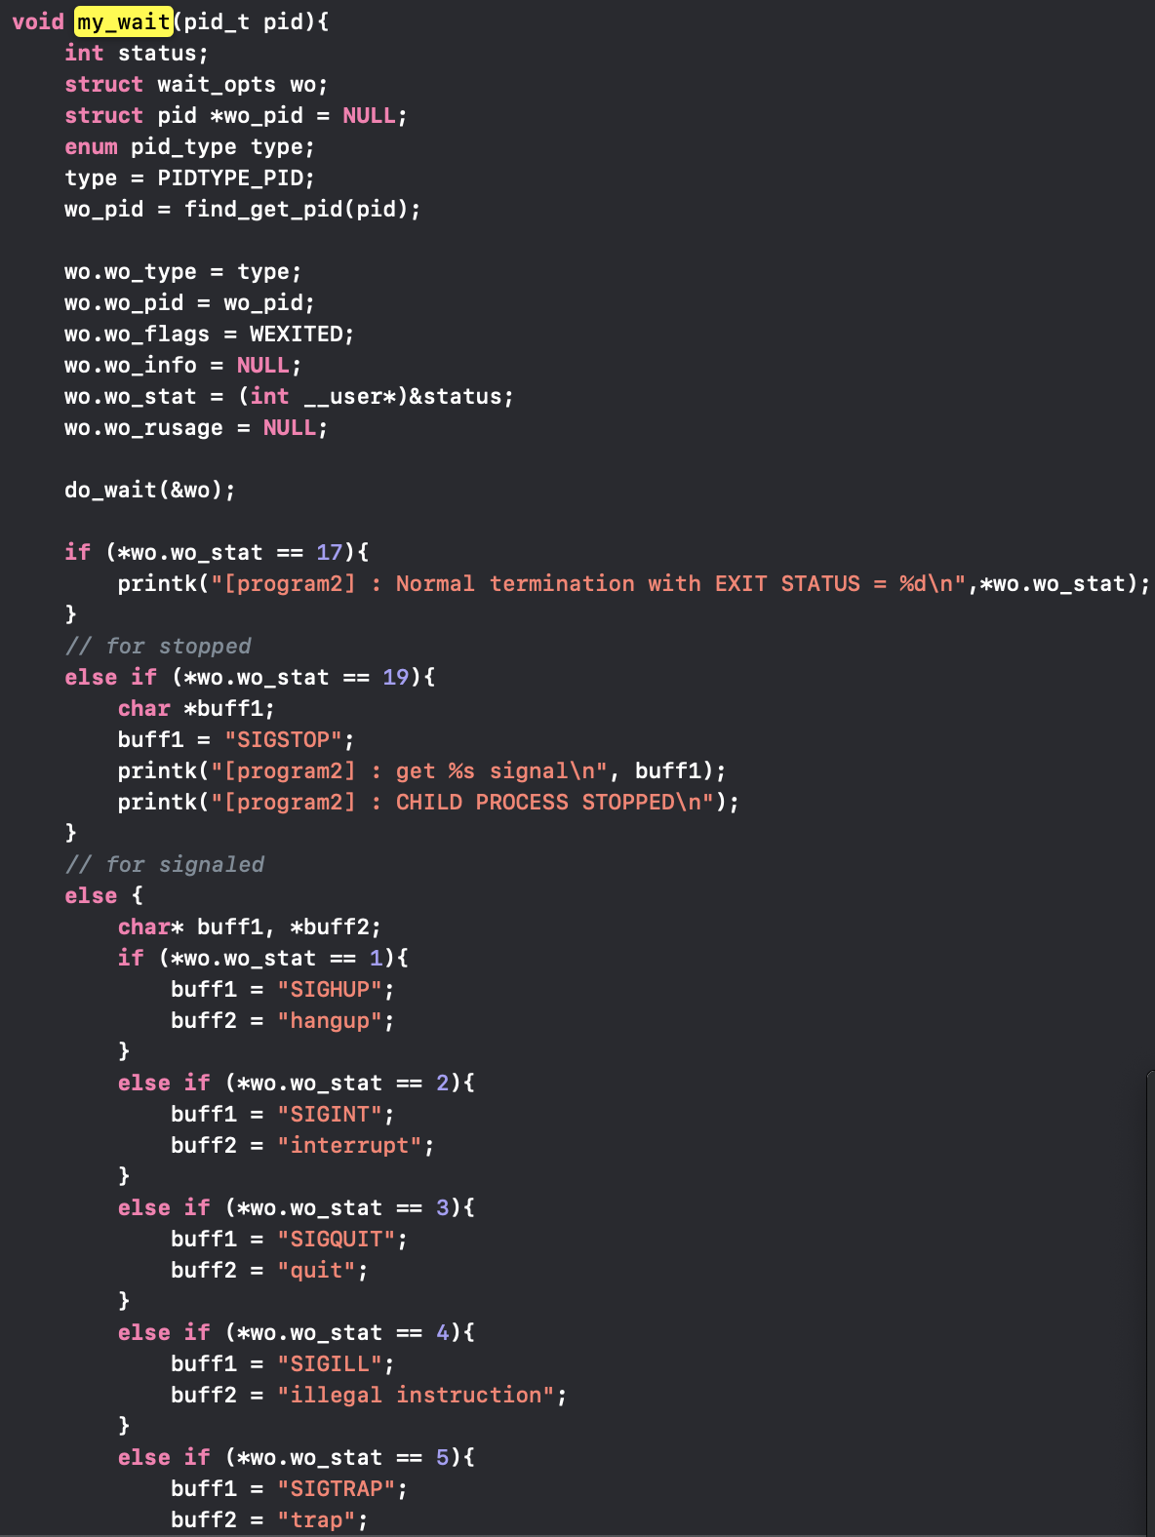

(The flowchart for program2 is shown below)



**Functions**

**void** my_wait(pid_t pid)function is used to let the parent wait for the child process while the child process is executing the test file. It is also able to catch and check the signal returned by the child process with *wo.wo_stat and print the signal in the kernel log.

1. It firstly, constructed a struct wo, which contains the pid type, wait options, pid, signal, termination status, information, resources usage and task wait queue from the child process.
2. Then, it constructed a struct pointer which is wo_pid.
3. It also let the parent process to wait for the child process to finish by using the do_wait() function from the kernel file.
4. It is also able to check the returned signal type by *wo.wo_stat value.
5. Finally, it frees the memory using put_pid() function.

**int** my_fork(**void** *argc)function is used to fork the child process and let the child process automatically execute the my_exec() function.

1. It will firstly set the default sigaction for the current process.
2. It will fork the child process and let the child process execute the my_exec() function by using the _do_fork function from the kernel file.
3. It will call my_wait function to let the parent process wait.

**static** **int** __init program2_init(**void**) function is used initialize the kernel module and create a kernel thread with the the __init program2_init(void) function.

1. It will firstly create the kernel thread with the kthread_create()function, it will automatically call the my_fork function function by sending the pointer of my_fork into the function as a parameter.
2. It will check if the kernel thread is started or not by using the IS_ERR(task) function.
3. If the kernel thread is created successfully, the function will wake up the process by wake_up_process(task)function.

**static** **void** __exit program2_exit(**void**)this function is used to exit the program2 when the process is finished.

**int** my_exec(**void**) this function is used to execute the external test file.

1. It will firstly get the path of test file and the system environment set.
2. It will get the filename using the getname() function from the kernel file and put it into the struct.
3. It will execute the test file using the do_execve() function and put the return value into the result variable.

**Results**

The result for program 2 is

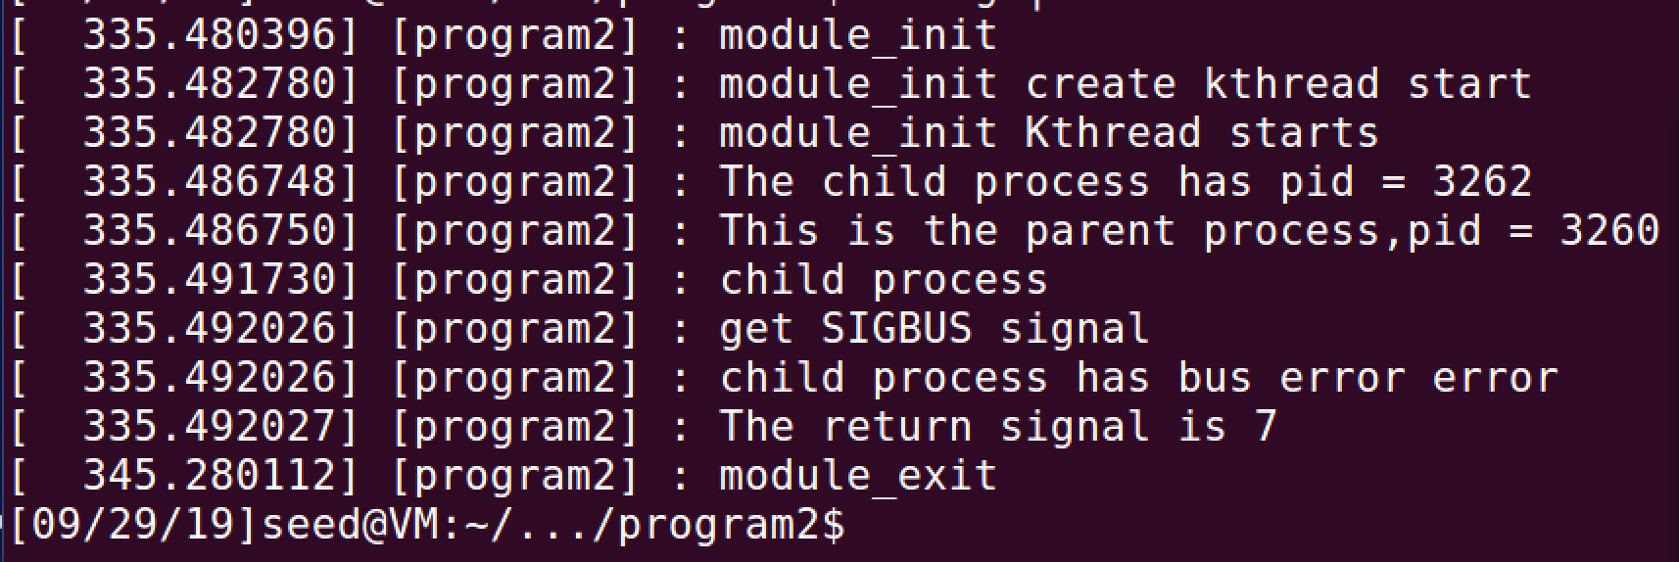

**Conclusion: What I have learnt from this program**

In this program I have learnt how to (1) fork a child process in kernel mode, (2) how to let the child process execute the external program in kernel mode, (3) how to let the parent process wait for the child process to terminate in the kernel mode and (4) how to handle the signal in kernel model.

1. How to Fork a Child Process in Kernel Mode

We use do_fork function load a child process in the kernel module. After the function executed, it is loading the kernel fork.ko module.

The function will return the pid of child process and we can also use the current -> pid to get the pid of the current process.

1. How to Let the Child Process Execute the External Program in Kernel Mode

We use the do_execute or _do_execute function to let the child process execute the external program in kernel mode. It will return the non-zero value if the execution succeeds otherwise it will return 0. The child process will not execute any lines in the original file after the execution function.

1. How to Let the Parent Process Wait for the Child Process to Terminate in the Kernel Mode

It will need the struct wait_opts and do_wait function to let the parent process wait. Wait_opts is a struct which contains multiple of process information. It also needs to decrease the count and free the memory after do_wait function.

1. How to Handle the Signal in Kernel Model

We use the *wo.wo_stat or the status form the wait_opts to determine the return signal

1. Additional

In order to execute the exit function, we need to firstly remove the kernel module from the kernel.

**Bonus Task**

**Introduction: Environment and Steps to Compile**

This program is written to implement the functions which is able read multiple test programs and recursively fork the child process (the proceeding one is the parent of the process of the later input file). The program is able to return the pid of each process including the main process of “myfork” file and is also able to return the signal raised in each input file. The program is implemented on C programming language on ubuntu (ubuntu version 16.04 and kernel version v4.8.0-36-generic). The user should input multiple test external file (no less than one file and no more than 99 files) and the output will be the pid of each process and the signals raised in the files.

This program will only support 15 signals which are:

SIGHUP, SIGINI, SIGQUIT, SIGILL, SIGTRAP, SIGABRT, SIGFPE, SIGKILL,

SIGBUS, SIGSEGV, SIGPIPE, SIGALARM, SIGTERM, SIGSTOP, SIGCHIL

Your command in your terminal should be like:

sudo make clean

sudo make

./myfork filename1 filename2 filename3

(the filename here should be the name of your external test file, the command should be under the program1 folder)

For example, your input file should be:

#include <stdio.h>

#include <signal.h>

#include <unistd.h>

#include <stdlib.h>

**int** main(**int** argc,**char**\* argv[]){

printf("------------CHILD PROCESS START------------\n");

printf("This is the SIGKILL program\n\n");

raise(SIGKILL);

sleep(5);

printf("------------CHILD PROCESS END------------\n");

**return** 0;

}

}

For example, the corresponding output file should be:

﻿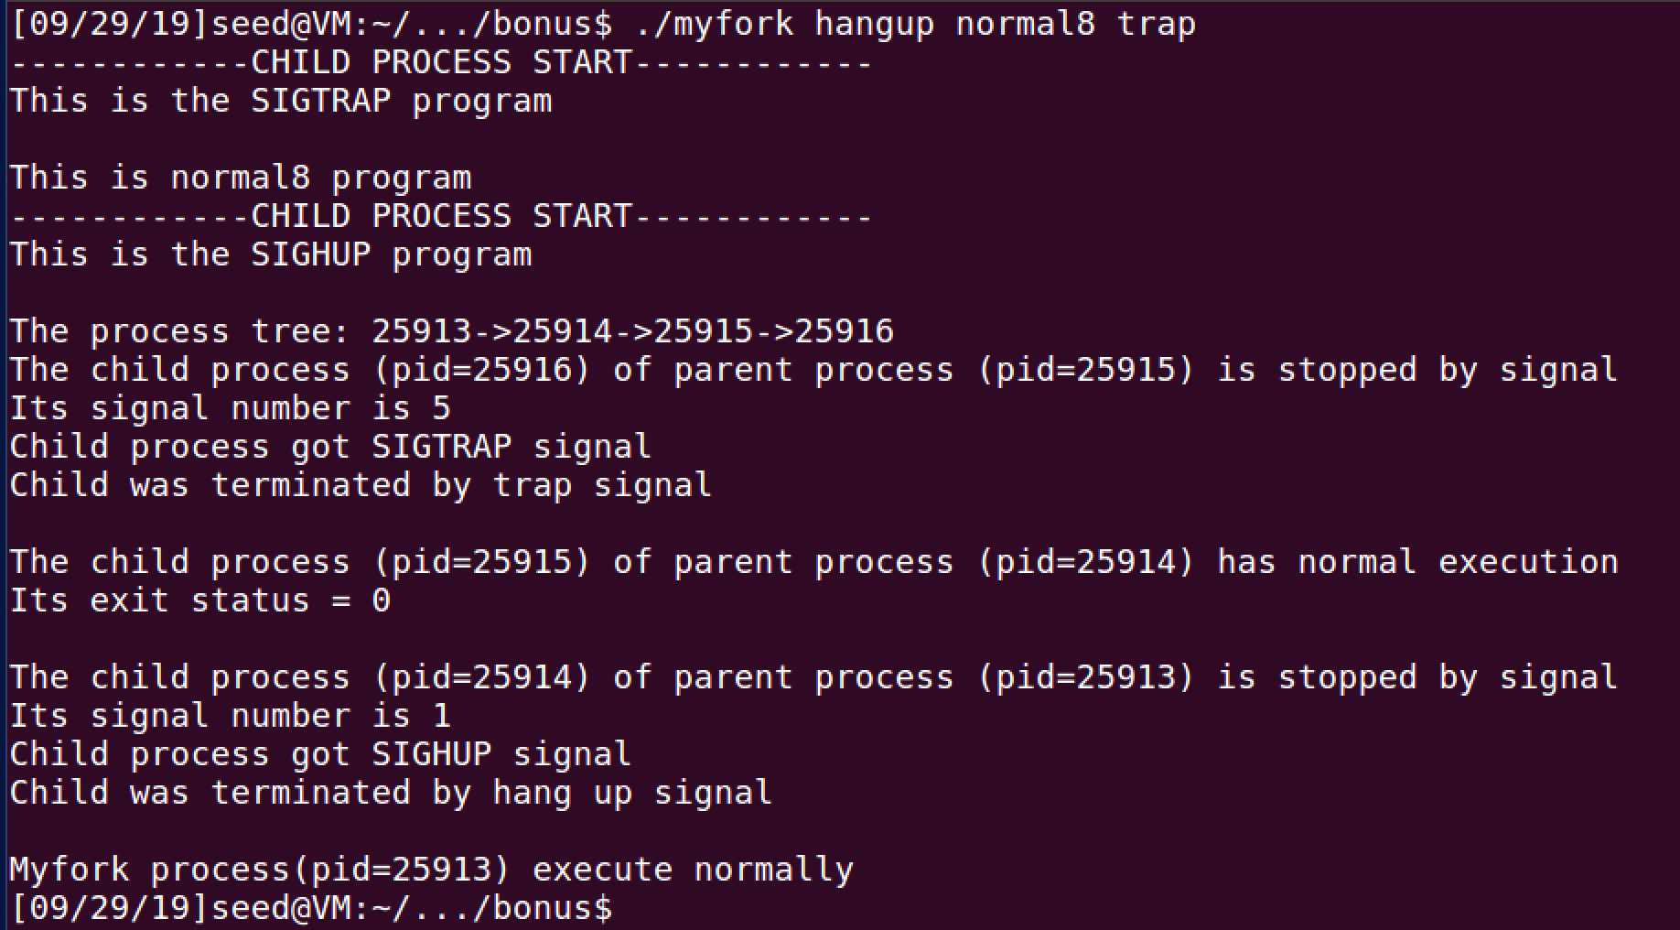

**Flow: How Did I Design My Program**

We implement the program with the idea of recursion and store every signal and pid in two arrays which are signal_array and pid_array with the size of 100.

1. We first read every input file and put the test files into a character array (exclude the myfork file). The integer variable argc is the number of the input file (include the myfork file).
2. If the input file is no more than 1, the program will return the “Invalid input” error and exit with error.



1. Then the main function will call the execution_recursion function with the initial index of 1 and totally input number of argc -1 and the file list arg.
2. We will do the recursion in the execution recursion function. Whenever the function is called it will fork a child process with the vfork() function since we need the parent and the child process to share the variables.
3. As long as the process is not for the last input file, the child process will continuously call the recursion execution function.
4. The parent process will catch the signal and pid of their child process and put the signal and pid value into the signal_array and pid_array respectively. Parent process also need to execute the input files in order to pass signal and pid information to their parent unless it does not have the parent process (index != 1).
5. When we reached the process for the last input file. We will execute the last file in the input file.



1. After we get the full pid_array and signal array, we print the process tree. The first pid value in the process tree should be the value of current process(myfork). After that we will print the element from the pid_array from the first element to the last. 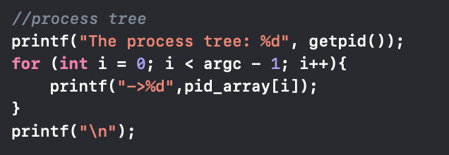
2. We continuously print the information of each process by fetching the value from the pid_array and signal_array

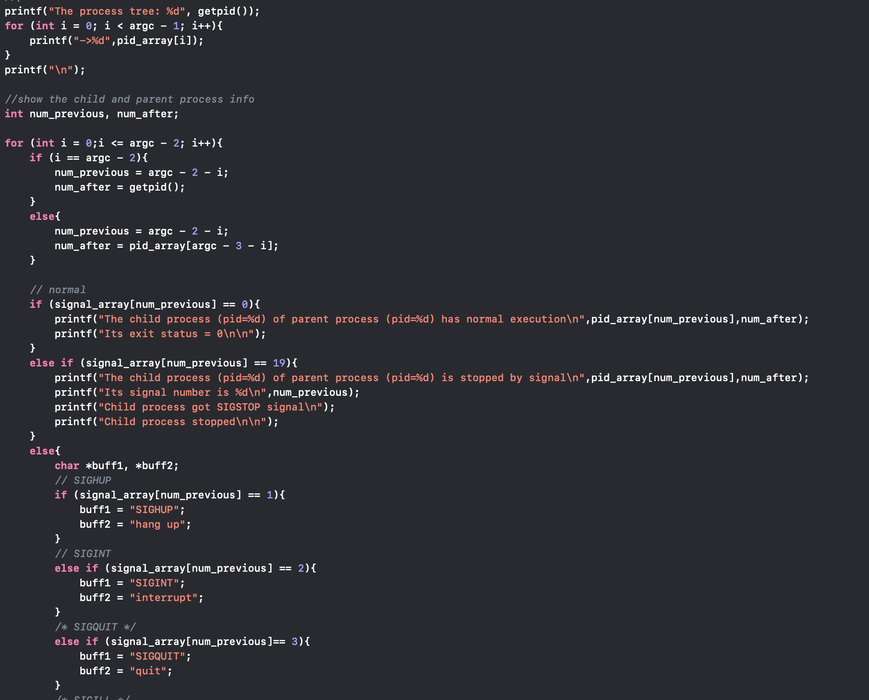

**Results: Screen Shot of My Output Result**

The result for not enough input

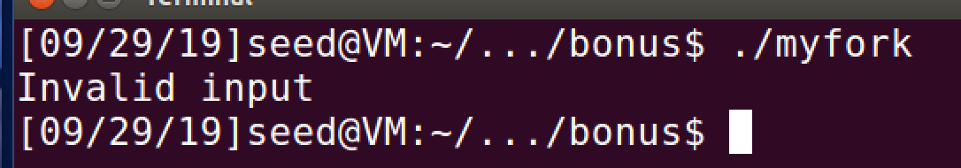

The result for single input hangup test file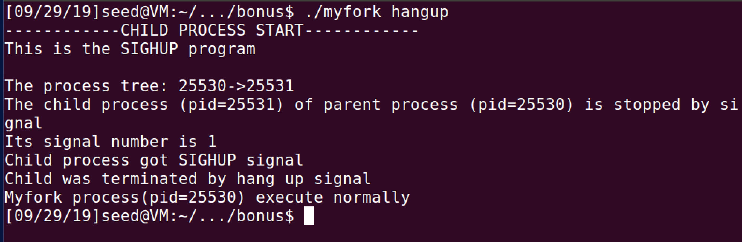

The result for two input files: hangup and normal8

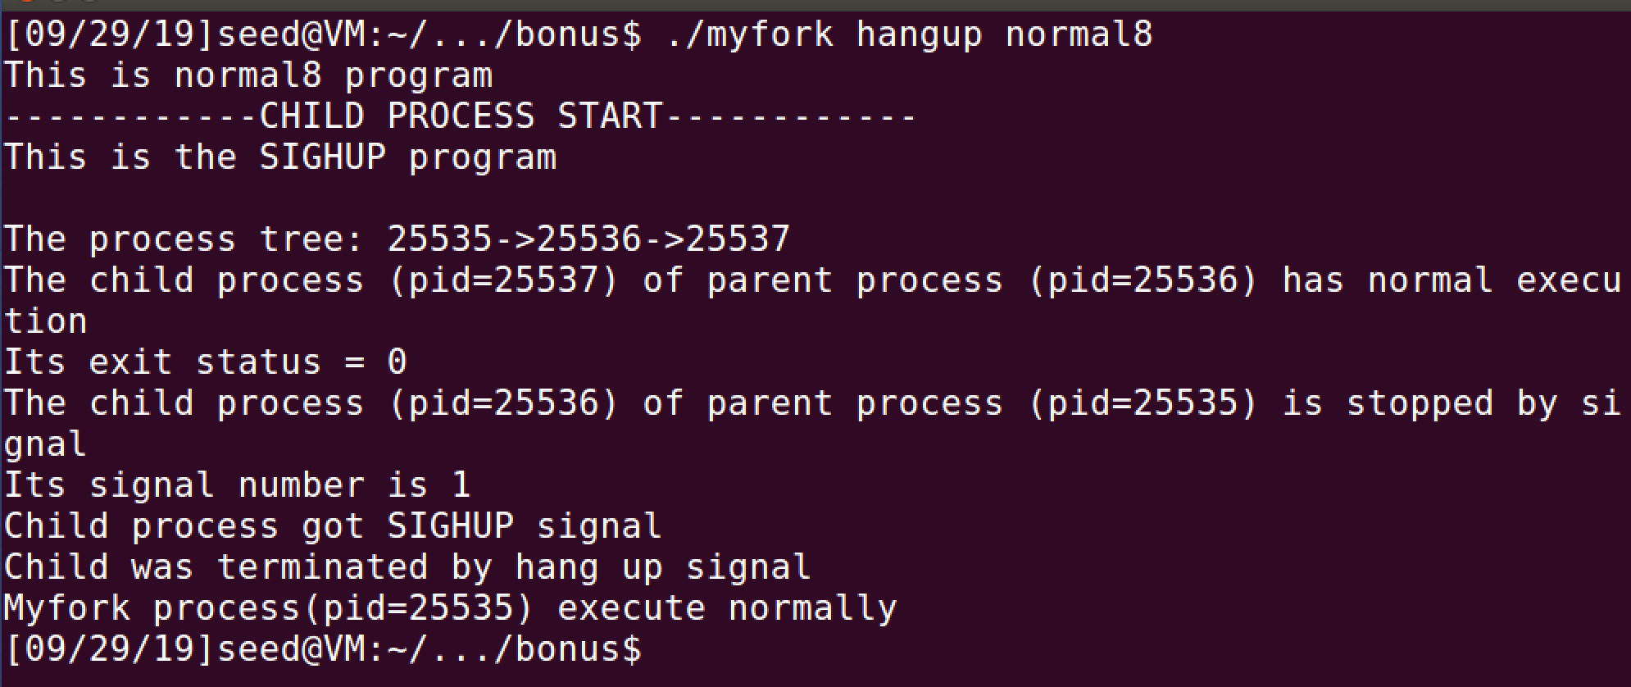

The result for three input files: hangup normal8 and trap

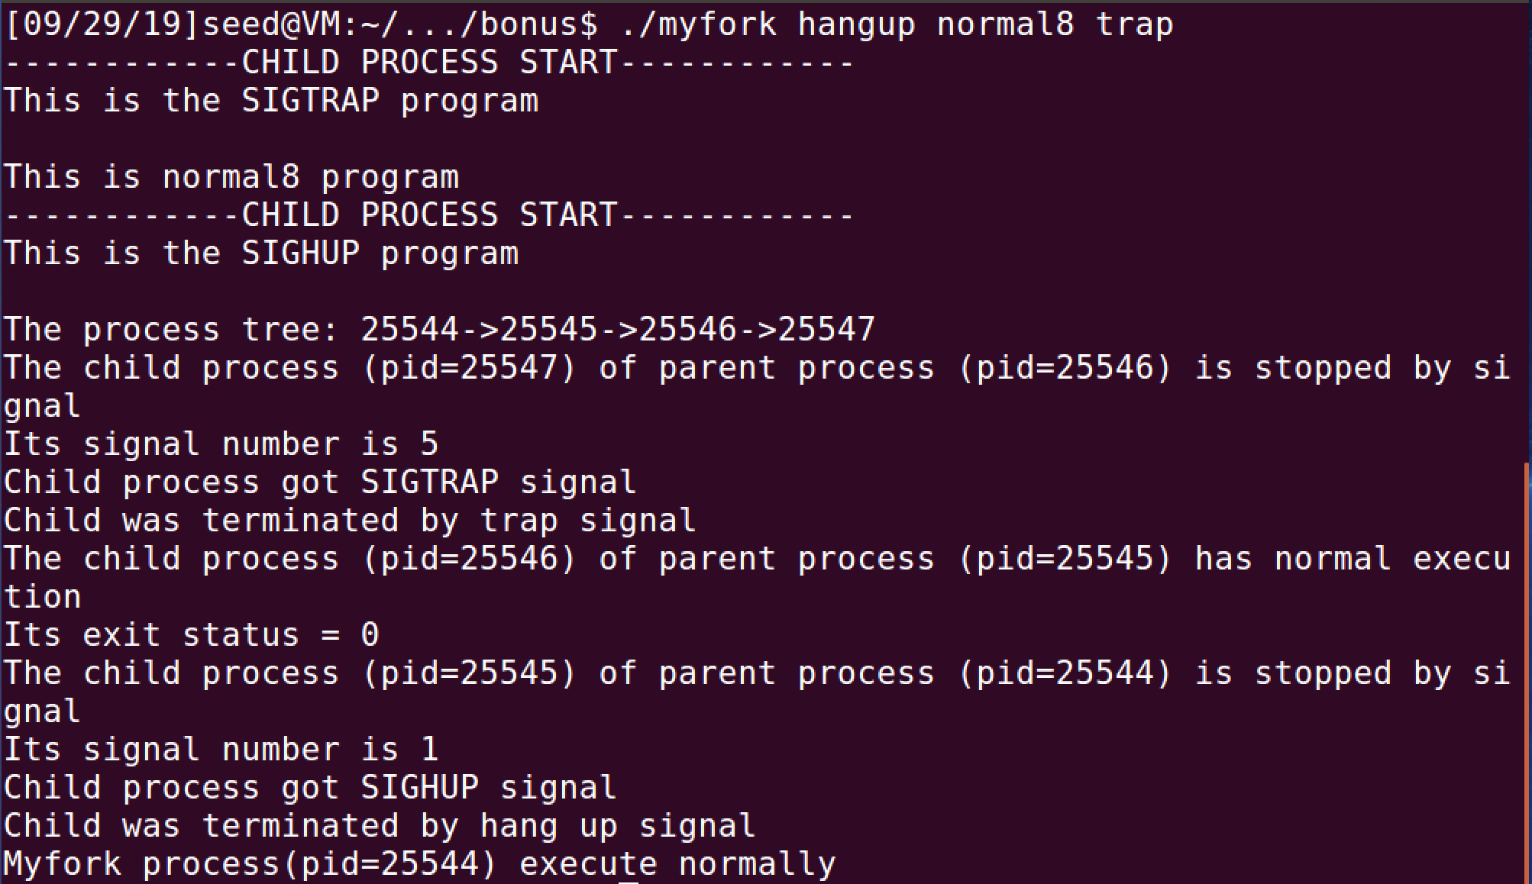

**Conclusion: What I have learnt from this program**

In this program I learnt that

1. If we want to let the processes share the variables we can use vfork() function to fork a child process.
2. How to use the recursion to continuously fork the child process and execute the external file.
3. How to manipulate multiple processes.
4. With the vfork function the program will always execute the child process before the parent process.